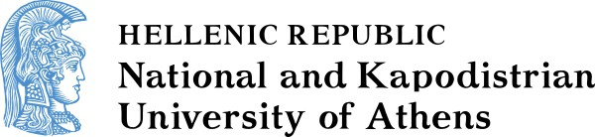

SCHOOL OF ECONOMICS AND POLITICAL SCIENCES
DEPARTMENT OF COMMUNICATION AND MEDIA STUDIES

MSc in MEDIA AND REFUGEE / MIGRATION FLOWS
APPLICATION FORM for the Academic Year 2024 - 2025
FAMILY NAME:  GIVEN NAME:  FATHER’S NAME:  MOTHER’S NAME:  HOME ADRESS:  POSTCODE:  COUNTRY:  PHONE NUMBER (RESIDENCE):  MOBILE NUMBER:  E-MAIL:  Included:  - Photocopy of Identity Card (two sides) or Passport  - Detailed CV (Europass)  - Copy of degree  - Copy of grades transcript  - Proof of English language (level C1)  - Two letters of recommendation  - Consent form  - Copy of thesis or title and a summary or reference that it is not mandatory for the candidate’s first-cycle program  - Academic papers, published either in journals or in the proceedings of international conferences  - Any other relevant information | To the Coordinating Committee  of the MSc "Media and Refugee/ Migration Flows"  National and Kapodistrian University of Athens  Department of Communication and Media Studies  1 Sophocleous Str., 105 59 Athens, 1st floor, Room 104, Office of Postgraduate Studies  Please consider my application for participation in the Postgraduate Program  MSc "Media and Refugee/ Migration Flows"  Specialization (1) - News media of refugee flows  Specialization (2) - Communication management of refugee/migration flows  Specialization (3) - Cultural Mediation  (You can choose two or even three specializations. Besides, the final declaration is made before the beginning of the second semester).  The Applicant  ____________________________________  (Date & Place, e.g. Athens, Madrid etc.)  __________________________________  (Signature)

migromedia.gr
migromedia@media.uoa.gr

